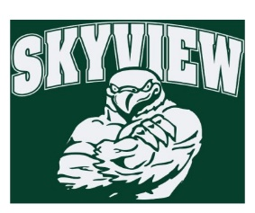
10.29.17 Edition
HAWK HAPPENINGS

Yankee Candle – Our contest winner will be announced next week! The incentive to tape our Principal to a wall has concluded. However, our on-line store will be open until January 2018! Yankee makes the best gifts and better yet, Skyview earns 40% of sales! There are three ways to obtain sales: 1.Share the catalog with family and friends 2.Online Sales ‐ set up a seller’s login at www.yankeecandlefundraising.com 3.The New Mobile App – download Yankee Fundraising at Google Play or Apple App Store
Contest Sale Starts: 10/10/17 Contest Sale Ends: 10/24/17 Delivery: Week 12/4/17 Skyview Group #: 999971230 www.yankeecandlefundraising.com Any questions please contact Courtney Kusy at courtcopp621@gmail.com
First Friday’s –Starting in November 3. Join Skyview staff and wear Skyview spirit wear the first Friday of every month to show your school spirit! Skyview apparel is available for purchase at yourstartingineup.com. All items can be customized with a school logo, your name, and more.
***FLASH SALE***
It's not too early to start your holiday shopping! Why not start on Halloween? All day on October 31, enter code "Spooky2017" to receive at 15% off discount on any order totaling $35.00 or more. Cannot be combined with other discounts. Not valid on existing orders. One use per customer.
All sales benefit your child's school. All items are custom and take 2-3 weeks for delivery! www.yourstartinglineup.com.
Directory –Student directories will be distributed early November.
Dine Out Night –Buffalo Wild Wings is supporting Skyview for the entire month of October. Must show flyer on phone or print. Be sure to order your wings for the football games!!
Skyview Bowling Club – Reminder, there is no bowling this week. November 7th is now a bowling date.
Boxtops –The winning classroom will be announced next week. The winning class gets a snack (all allergies are accounted for).

